Personal Portfolio
Initial Prompt
Create a modern, professional personal portfolio website for a Bachelor of Science in Information Technology (BSIT) student.
The design should be clean, minimal, and tech-inspired, using a dark or light theme with accent colors like blue or purple. The website must be responsive and suitable for both desktop and mobile.
Include the following sections:
Hero Section (Landing Page):
Name: [Your Name]
Title: BSIT Student / Future Software Developer
Short tagline: “Building solutions through code and technology”
Include a profile picture and a call-to-action button (e.g., “View My Work” or “Contact Me”)
About Me:
A short introduction about me as an IT student
My interests (programming, web development, systems, etc.)
My goals (e.g., becoming a developer, cybersecurity expert, etc.)
Skills Section:
Programming languages (e.g., Python, Java, C++)
Web development (HTML, CSS, JavaScript)
Tools (Arduino, Git, MySQL, etc.)
Use progress bars or icons for visual appeal
Projects Section:
Showcase 3–5 projects with descriptions
Include: project title, short explanation, technologies used
Example: “Arduino Egg Sorting System using Load Cell and Servo Motors”
Add buttons for GitHub or live demo (if available)
Education:
BSIT degree details
School name
Relevant coursework or achievements
Contact Section:
Email
Phone (optional)
Social links (GitHub, LinkedIn, Facebook)
Contact form
Design Requirements:
Smooth scrolling
Subtle animations
Modern fonts
Use icons for skills and contact
Clean layout with good spacing
Make the tone professional but approachable. The portfolio should highlight technical skills, projects, and potential as an IT professional.
use color orange and blue any shades if you want.

Refinement Prompts (at least 2 more)
change the dean's lister and change the name to Aaron Ace Tangcay and email to aaptangcay@gmail.com

university name Ateneo de Davao university remove the Year, and the senior high school is st. John Paul ii College of Davao (2018 -2020) abm strand

use this for the photo
(my 2x2 photo)

Screenshots of Outputs and Website link
https://it-portfolio-showcase--desireemg11.replit.app/
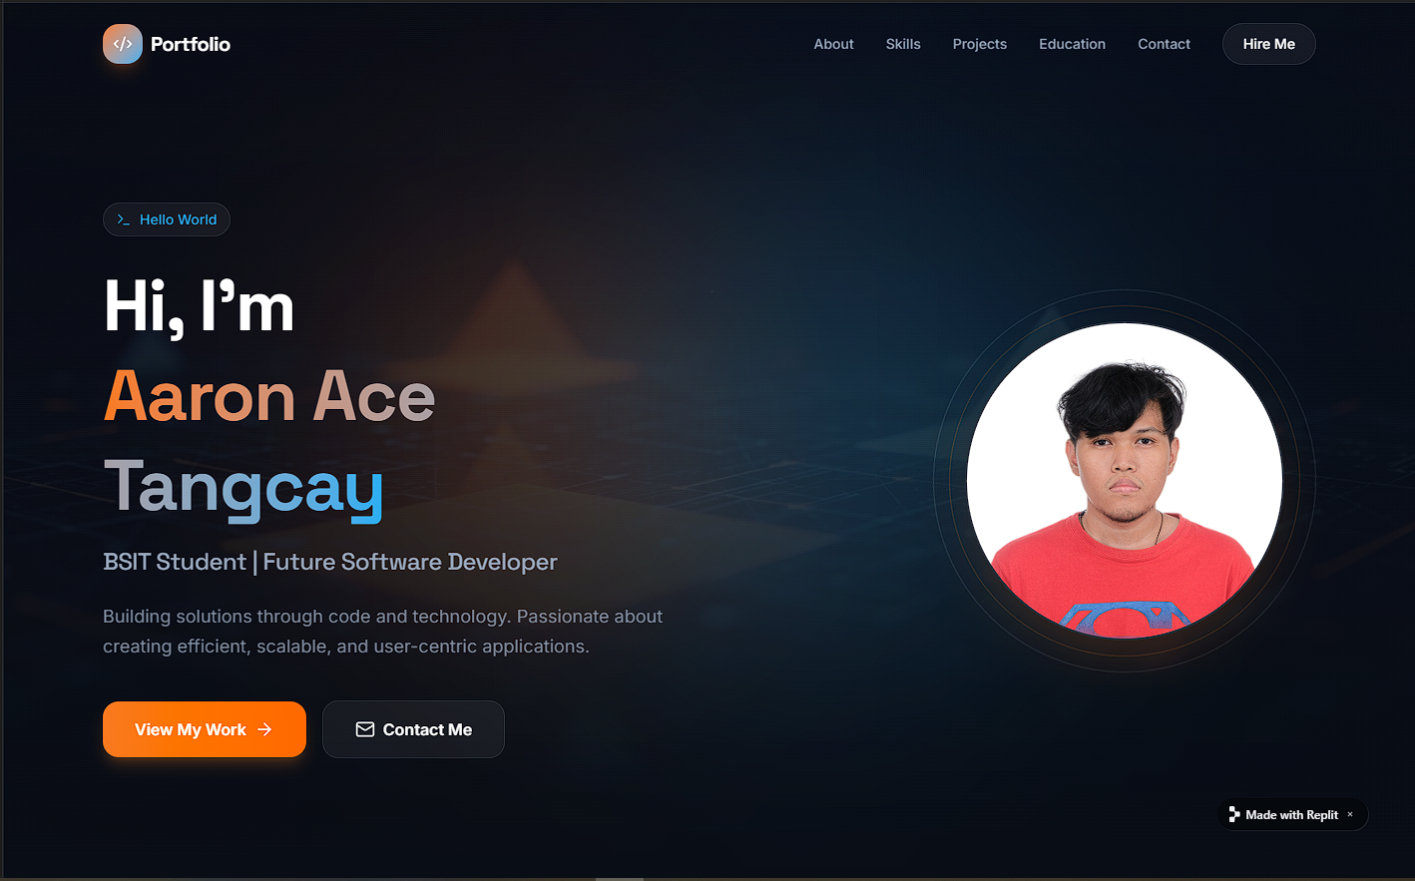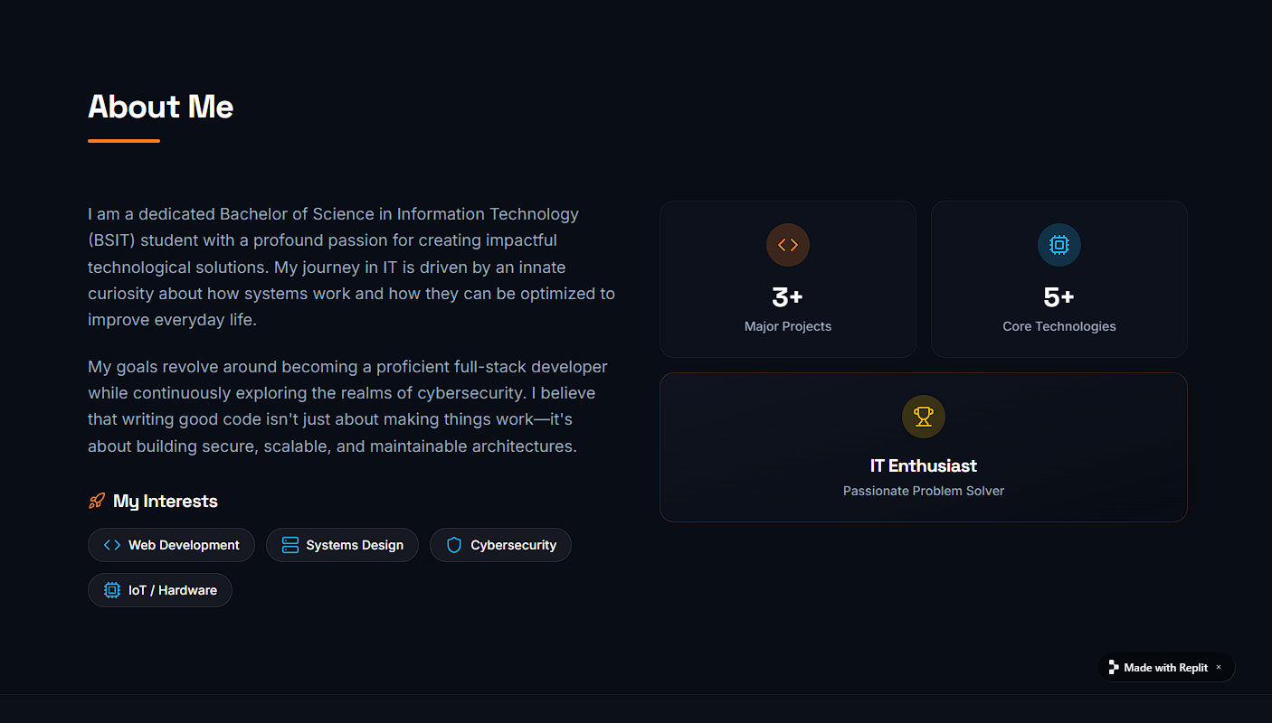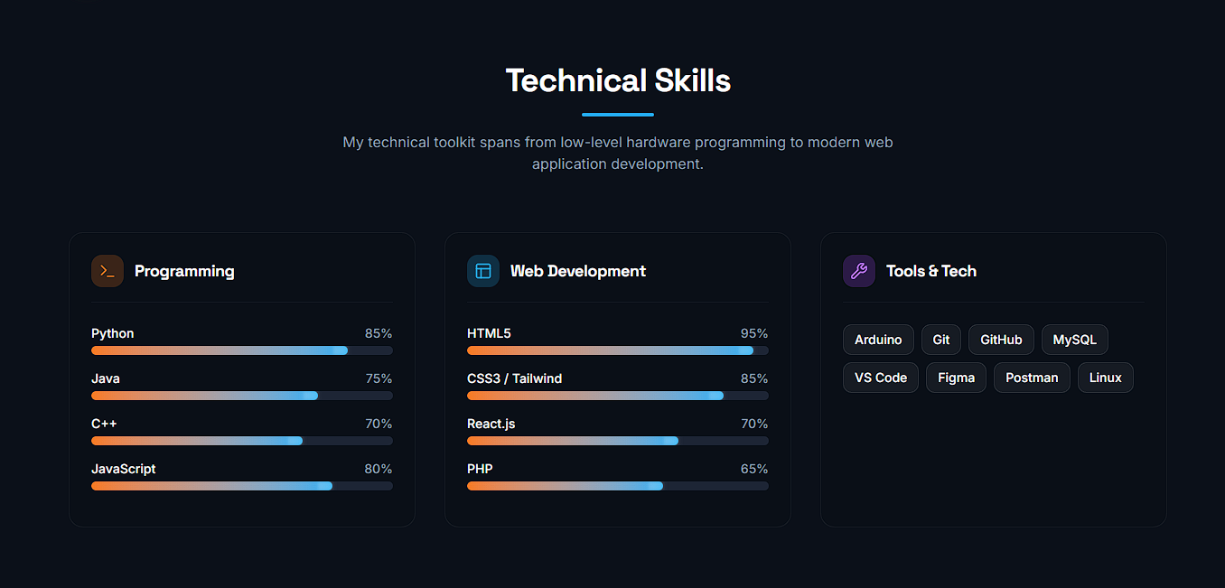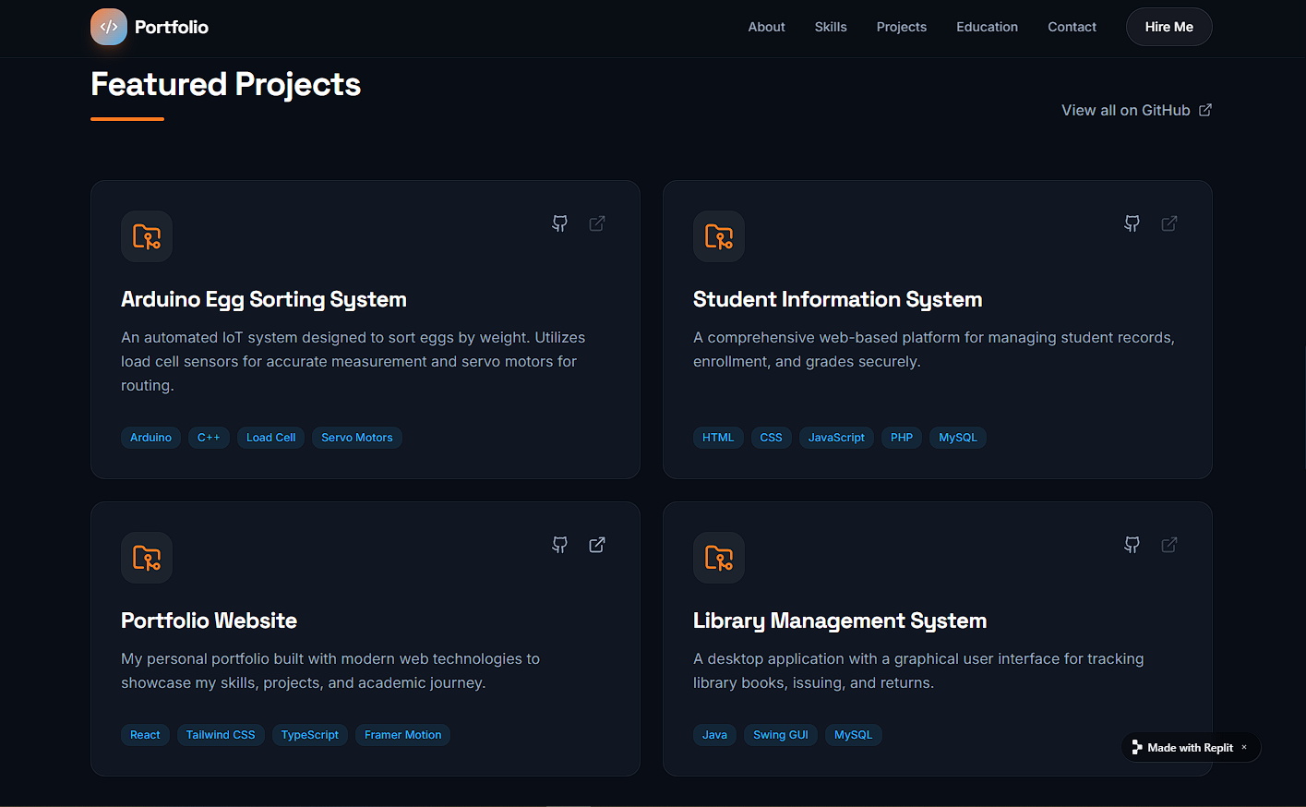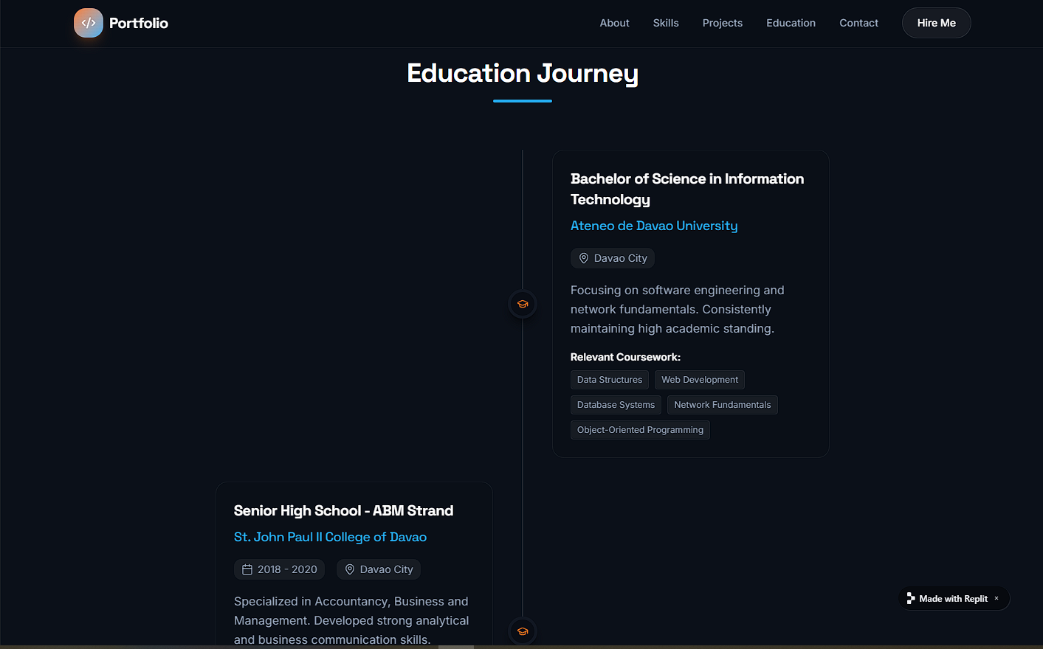
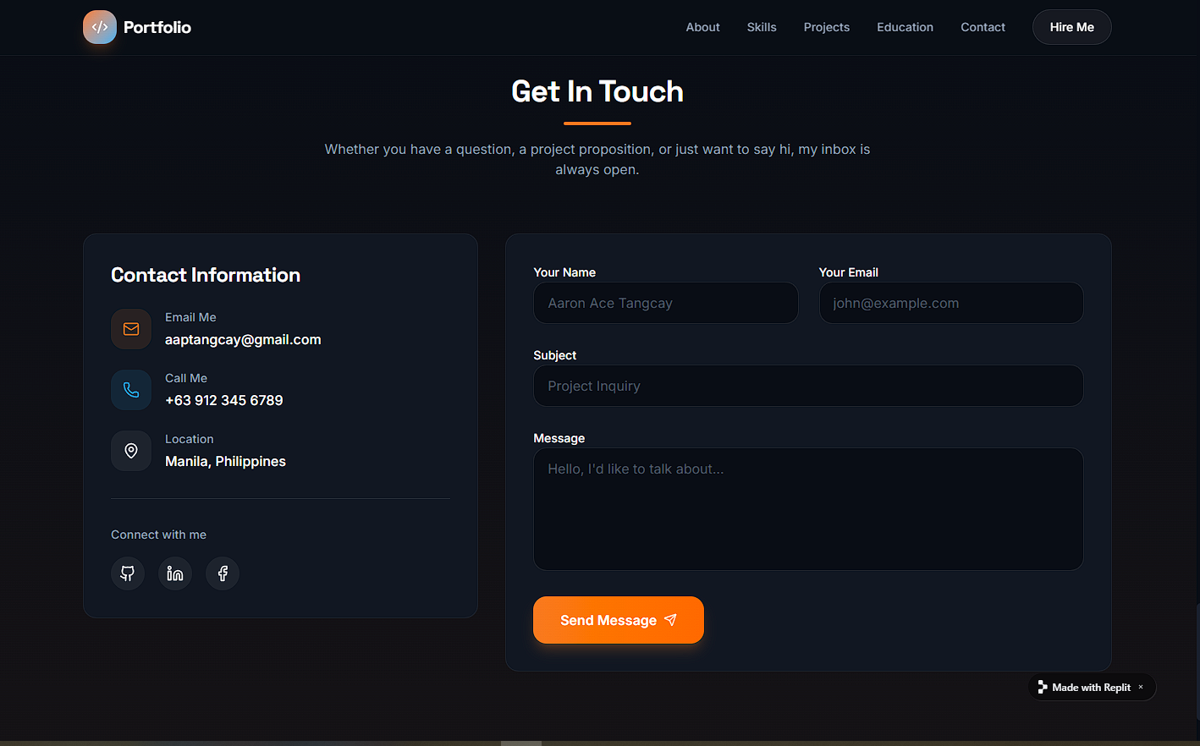

Final Reflection:
What worked well?
What worked well for me was how the AI helped me quickly generate a complete structure for my personal portfolio. It gave me a clear layout—from the hero section to the projects and contact page—which saved me a lot of time planning. The design suggestions were also helpful because they already followed a modern and clean style, so I didn’t have to start from scratch. It made the whole process faster and more organized.
What needed manual fixing?
Even though the AI generated a good starting point, I still had to manually fix and improve several parts. Some content felt too generic, so I had to personalize it to reflect my actual skills, projects, and experiences as a BSIT student. I also adjusted the wording to sound more like me. In terms of design, I needed to tweak spacing, alignment, and sometimes the responsiveness to make it look better on different screen sizes. Small details like project descriptions and section flow required my own input to make the portfolio feel authentic.
What did you learn about prompting?
I learned that the quality of the output really depends on how clear and specific the prompt is. When my prompt was too general, the results were also generic. But when I added more details—like the sections I wanted, the style, and the type of content, the AI produced much better and more usable results. I also realized that prompting is not just a one-time thing; it’s a process. I had to refine and adjust my prompts multiple times to get closer to what I wanted. Overall, I learned that good prompting is about being clear, detailed, and willing to iterate.

